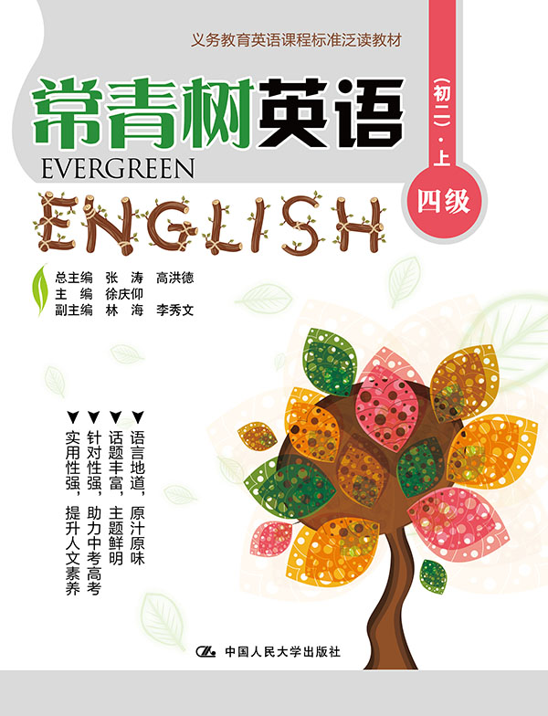
书名：常青树英语 四级（初二）·上
书号：978-7-300-21867-0
作者：高洪德 张涛 徐庆仰
责任编辑：王琼 黄婷
成品：177*228 页数：207
纸张：70克高白胶
装祯：平装
出版时间：2015年9月
定价：39.00元
出版社：中国人民大学出版社

- 本书卖点
- 语言地道、原汁原味
- 话题丰富、主题鲜明
- 针对性强、助力中考高考
- 实用性强、提升人文素养

◆ 读者定位
初中生

- 作者简介
高洪德，山东省教学研究室英语教研员、特级教师，中国教育学会外语教学专业委员会副理事长、山东省教育学会外语教学研究专业委员会理事长。
张涛，山东省教育学会外语教学研究专业委员会秘书长、山东省教学研究室英语教研员。

- 内容简介
《常青树英语 四级（初二）·上》适合初中起始年级学生使用，所选篇章以《课标》24个话题为主线，题材涵盖广泛，体裁包括故事、新闻、诗歌等，内容以学生的兴趣为切入点，贴近学生的生活，符合学生的认知经验和水平，渗透语言文化，有利于提高学生的学科素养。

◆ 简要目录
Lesson 1 A Sweet Job
Lesson 2 Father’s Love
Lesson 3 Hellen Keller
Lesson 4 Marco Polo
Lesson 5 A Special Good Friend
Lesson 6 Bird Friends
Lesson 7 A 3-year-old Girl’s IQ Is Too High to Be Calculated
Lesson 8 And the Next Unit Is…
Lesson 9 Tomb Sweeping Day
Lesson 10 An Art of Understanding
Lesson 11 Bob’s Hobby
Lesson 12 Volunteering
Lesson 13 Uniforms
Lesson 14 Thankful Thursdays
Lesson 15 A Boy and the Highest Mount
Lesson 16 Middle School Life in France
Lesson 17 The Feeling of Happiness
Lesson 18 The Fox and the Goat
Lesson 19 A Touching Scene
Lesson 20 Sam and Harry
Lesson 21 My Favorite Activities
Lesson 22 Collecting as a Hobby
Lesson 23 The Soldier and the Horse
Lesson 24 A Child’s Angel
Lesson 25 The Prince and the Prisoners
Lesson 26 New Tourist Law
Lesson 27 Railway Signals
Lesson 28 The Solar-powered Plane
Lesson 29 Addicted to Tablets?
Lesson 30 Too Much Help Online?
Lesson 31 A Goal for Life
Lesson 32 Finding Time to Have Fun
Lesson 33 My Shopping Experience
Lesson 34 Lucky Customer
Lesson 35 In a Clothing Store
Lesson 36 Eating Habits in the Indian Culture
Lesson 37 The Best Food in the World
Lesson 38 Food Customs in Norway
Lesson 39 How Much Water Do You Really Need?
Lesson 40 Be Careful about Energy Drinks
Lesson 41 Junk Food Should Be Stopped in School
Lesson 42 A Hero
Lesson 43 Notes against a Big Earthquake
Lesson 44 Keeping Safe in the Car
Lesson 45 Trade Favors
Lesson 46 Quvenzhane Wallis
Lesson 47 Ed Sheeran
Lesson 48 A New Source of Energy: Wind
Lesson 49 Different Weather Makes People Feel Different
Lesson 50 Can We Change the Weather?
Lesson 51 Robots
Lesson 52 Nubrella
Lesson 53 An Experiment
Lesson 54 I Hear America Singing
Lesson 55 Follow Your Own Course
Lesson 56 Be Thankful
KEY

◆ 上架建议
中学英语泛读读本

书摘
Lesson 30 Too Much Help Online?
Guidance
Nowadays, more and more students search information online when doing homework. 网络是学习的好帮手，但不能过分依赖哦。

What will you do when you have difficulties with your homework? Lu Lifei, 14, from Jiangsu, likes solving his problems with a smartphone.
Nowadays, many students do homework with the help of the Internet, just like Lu. They search information online, use apps or discuss on social networks like QQ and WeChat.
“It’s convenient. You don’t have to wait or get a tutor by your side,” Lu said. “You also learn by seeing others work them out.”
It also helps improve students’ ability, said Wang Shiying, 15, from Shanghai. And it’s especially true for new types of homework.
Wang’s Chinese teacher often asks students to give lectures on great authors. When it comes to Wang’s turn, she usually searches online, picks out certain stories and makes PowerPoint presentations. “I’ve become skilled at finding information online and using Microsoft Office,” Wang said.
However, this also brings up problems. Some students just copy the answers online without thinking. They become lazy and don’t like to think.
Huang Pengxiang, a head teacher from Shanxi said that knowing how to use the Internet is important. The key is to have good self-control.
“No matter how difficult the problem is, think about it independently first,” Huang said. “Be sure to understand the reasons behind the answers, or you won’t improve. If you’re not confident about your self-control, ask your parents for help.”

